List of Household Living Standards Survey Interviewers

Last name, first name, patronymic of the interviewer |  | Surveyed locality
Mukasha Shnar  Tolegenovna |  | Pavlodar c.
Sharipzhanova  Rymkesh Abdykarimovna |  | Pavlodar c.
Akhmetbekova  Daria Daniyarovna |  | Pavlodar c.
Akhmetova Nazira  Kayrullinovna |  | Pavlodar c.
Beisekenova  Madina  Aspandiyarovna |  | Pavlodar c.
Omarbekova  Nazgul  Zeynullaevna |  | Pavlodar c.
Akhmetbekova  Ainura Amantaevna |  | Pavlodar c.
Aliasova  Farida Aitmukhamedovna |  | Kenzhekol r.d.
Taldatkyzy  Madina Lashimova | 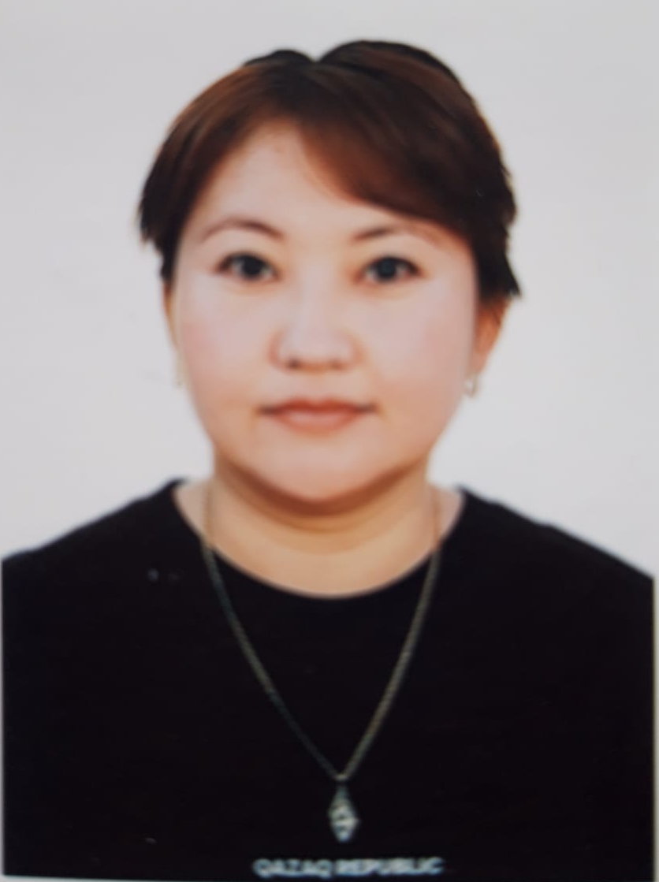 | Aksu c.
Myltykpaeva Aigul  Shalabaevna |  | Aksu c.
Fomina  Lyudmila Vladimirovna |  | Kalkaman v.  Aksu c.a.
Turumtaeva  Ainur Zholdybaevna |  | Ekibastuz c.
Katarova  Diana Tanatarovna |  | Ekibastuz c.
Apergenova  Zhumagul Ziyadanovna |  | Ekibastuz c.
Aidarbekova  Nasip Maratovna |  | Akkol r.d.  Ekibastuz c.а.
Ilyaseva Kuralai  Kuandikova |  | Bayanauyl v.  Bayanauyl district
Babkina  Svetlana Leonidovna |  | Priirtysh r.d.  Zhelezinsky district
Kapezova  Albina  Askhatovna |  | Kyzylzhar r.d.  Irtysh district
Fedulova  Svetlana Grigorievna |  | Beregovoi r.d.  Terenkol district
Baytleuova  Zhanat Shokanovna |  | Akkuly v.  Akkuly district
Abylkarimova  Aliya Ibradimovna |  | Koktobe v.  Maysky district
Litvinenko Svetlana Anatolyevna |  | Efremovsky r.d.  Pavlodar district
Matveeva  Evgenia Alexandrovna |  | Rozhdestvensky r.d.  Pavlodar district
Erezhepova  Tatyana Andreevna |  | Uspenka v.  Uspensky district
Kasyanenko Elena Valerievna |  | Shcherbakty v.  Shcherbaktinsky district
Mandryka  Larisa Nikolaevna |  | Oryol r.d.  Shcherbaktinsky district

